**Practical 6**

Miqdad Rajkotwala, 50

**Aim- Basic Plotting function in MATLAB**

Plotting is a graphical representation of a data set that shows a relationship between two or more variables. MATLAB plots play an essential role in the field of mathematics, science, engineering, technology, and finance for statistics and data analysis.

There are several functions available in MATLAB to create2-dimensional and3-dimensionalplots.

In MATLAB, plotting is a fundamental tool for visualizing data and mathematical functions. It allows you to create visual representations of your data to gain insights, identify patterns, and communicate findings effectively. Here are some key theories and concepts related to plotting in MATLAB:

**1. Figure and Axes:**

* A **Figure** is a graphical window or canvas where plots are displayed. You can have multiple figures open simultaneously.
* Within a figure, you can have multiple **Axes**, which are individual plot areas. Each set of axes represents a separate visualization.

**2. Basic Plot Types:**

* **Line Plot**: Represents data points as a series of connected lines. Suitable for continuous data or time series.
* **Scatter Plot**: Visualizes the relationship between two variables using individual data points.
* **Bar Plot**: Represents categorical data with rectangular bars.
* **Histogram**: Displays the distribution of a dataset.

**3. Data Representation:**

* **x-axis and y-axis:** Represent the horizontal and vertical dimensions of the plot, respectively.
* **Labels:** Provide context to the axes, indicating what data is being represented.
* **Title:** Describes the overall content or purpose of the plot.
* **Legend:** Identifies different data series in the plot.

**Program :**

**1. Line Plot:**

A line plot is used to represent data points as a series of connected lines.

x = [1, 2, 3, 4, 5];

y = [2, 3, 1, 4, 7];

plot(x, y);

title('Line Plot');

xlabel('X-axis Label');

ylabel('Y-axis Label');

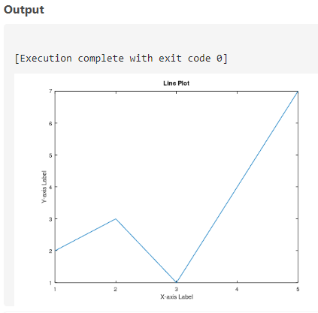

**2. Scatter Plot:**

A scatter plot is used to visualize the relationship between two variables.

x = [1, 2, 3, 4, 5];

y = [2, 3, 1, 4, 7];

scatter(x, y);

title('Scatter Plot');

xlabel('X-axis Label');

ylabel('Y-axis Label');

